

July, 2025 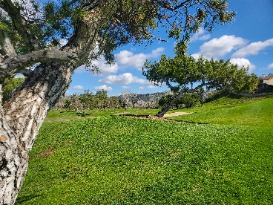

Well, we haven’t had a newsletter come out for quite a while. I was going to write one up when Steve Tugwell became our new President… but never quite got around to it. Then early this year I thought I would write one talking about our upcoming Sr. League season and how we are going to improve this year. But I didn’t … and alas, we haven’t. (But we are having a helluva lot of fun!) Then there was the new club rule about dancing girls on the fairway – but we decided to table that one.

Here it is July already and I keep hearing that I need to write another newsletter! OK, well maybe a few guys brought it up … actually, I think Bob Stuckey mentioned it once.

SO now I am announcing that the Twin Oaks Mens Club will hold a once-a-month Saturday event starting this month on the 26th. “Wait” you say “Don’t we already have a Saturday once-a-month tournament?” But - do we really? Oh, it’s scheduled alright …. but we barely have 4 foursomes each month. 16 out of a club of over 120 members is a bit pathetic I have talked with a few of you asking why we get such poor attendance. So, in honor of the great David Letterman, I give you:

The Top Ten Reasons Why TOMGC Saturdays Suck!

#10 “My wife wants to go see the Botanical Garden this Saturday.”

#9 “Saturday play doesn’t count for Player of the Year!”

#8 “It is so slow out there on Saturdays!”

#7 “It’s way too expensive on Saturdays.”

#6 “I can’t figure out that stupid DVR and I can’t miss Saturday sports!”

#5 “It’s too crowded on Saturdays!”

#4 “There are less lost balls to find on Saturdays”

#3 “I hear Saturday play is too clickish – I don’t think I will fit in.”

#2 “I’m retired – I don’t play weekends anymore.”

And the #1 Reason TOMGC Saturday Golf sucks…. “We play shuffleboard on Saturdays and have a standing early reservation at the Smorgasbord!”

Well guys, the reality is we play for a little higher stakes, so you can usually win more. It is only a few dollars extra for green fees, but it does count for Player of the Year. We play fairly early so it is not slower than Wednesday golf for the most part. It is true that there is a regular group on Saturdays – but heck they let me play so I guess everyone is welcome. And the big one – we play “Closest to the Pin” on Saturdays! (I knew you would like that)

Alright look for your email invite and come out and join us on the 26th of this month. Or stay home and pull weeds.

Jeff Boyer – Twin Oaks Men’s Club