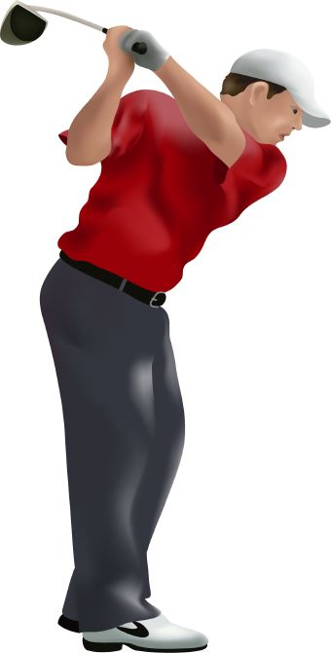 Twin Oaks Men’s Golf Club March 2017

The newest issuance of the Rules of Golf from the R&A and the USGA became effective on January 1st of last year. These two agencies alone, one in Scotland and the other in New Jersey, through this issuance, govern the game of golf worldwide. Their mission statement, if you will, would seem to be summed up by the opening quote found just inside the front cover of the most recent issue. It says, “Play the ball as it lies, play the course as you find it, and if you cannot do either, do what is fair. But to do what is fair, you need to know the Rules of Golf.” I don’t think anything could be clearer, except perhaps my complete lack of ability to anyone who has ever seen me play! The game is played under different conditions, by persons of all skill levels, at a great number of different venues. That being said, the one constant in all of that, is the rules by which the game is played! Please take the time to review the Rules of Golf at your leisure. Believe it or not, some of it actually starts to make some sense after a while. Never the less, the field of play, no matter where it might be, is kept level by the observance of these Rules of Golf.

Each new issue of the Rules of Golf includes a list of the principle changes at the very outset. This is a perfect place to begin a quick review of the Rules. By investigating these changes, you should become aware of what the Rule used to be so that you can understand how it has changed. The next section of the Rules of Golf, is a section entitled, “How to use the Rule book.” What could be easier, eh? If you pass the section on principle changes, do not pass the section on how to use the rule book, it will help guide you through the challenge facing all of us on understanding the Rules of the game we will strive to master for the remainder of our lives. The next two sections should also be a part of your first encounter with this book. Those are, “A quick guide to the Rules of Golf”, and the section on “Etiquette.”

Good luck with your investigation in to the Rules of Golf. As we move forward from here, I will attempt to discuss and re-discuss some of the more common Rules we encounter in most every round. When and how to play a provisional ball. When and how to take a proper drop. When and how to properly recover from a lost ball or a ball in a hazard. So until next time, please enjoy your game, and do all you can to help fellow club members enjoy their game.